WAVES: Scientific Investigation: Waves in Water

EXAM STYLE QUESTIONS (CRITERION B and C)
Scenario:
You are investigating how the depth of water affects the time it takes for a wave to travel a fixed distance in a container. You measured the time taken for waves to travel 1 meter at five different water depths: 5 cm, 10 cm, 15 cm, 20 cm, and 25 cm. The results of three trials are shown below:
Water Depth (cm) | Time (s) -  Trial 1 | Time (s) -  Trial 2 | Time (s) -  Trial 3 | Mean Time (s)
5 | 2.1 | 2.3 | 2.2 | 2.2
10 | 1.8 | 1.7 | 1.9 | 1.8
15 | 1.5 | 1.4 | 1.6
20 | 1.3 | 1.4 | 1.2
25 | 1.0 | 1.1 | 1.2 | 1.1

Criterion B: Inquiring and Designing
- Identify the independent and dependent variables in this investigation.
……………………………………………………………………………………………………………………………………………………………………………………
- Write a hypothesis for how the depth of water affects the time it takes for a wave to travel 1 meter.
……………………………………………………………………………………………………………………………………………………………………………………
- Explain one control variable and why it is important to keep it constant.
……………………………………………………………………………………………………………………………………………………………………………………

Criterion C: Processing and Evaluating
- Calculate the mean time for the water depths of 15 cm and 20 cm. Add these values to the table.
- Plot a graph of mean time (y-axis) vs. water depth (x-axis).
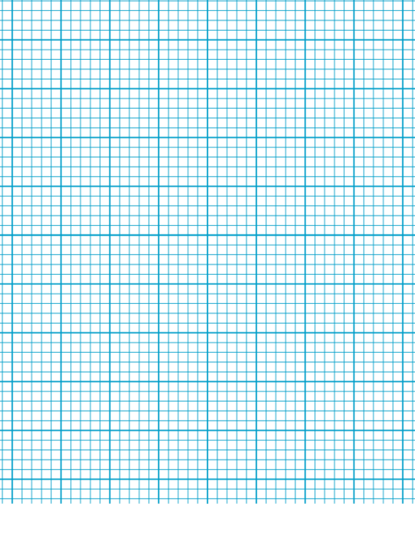
- Describe the trend shown by your graph.
……………………………………………………………………………………………………………………………………………………………………………………

- Evaluate your results: Do they support your hypothesis? Explain why or why not.
…………………………………………………………………………………………………………………………………………………………………………………………………………………………………………………………………………………………………………………………………………………………………………

